It has been 20 years have since the Kawartha Land Trust (then known as the Kawartha Heritage Conservancy) became a reality.

So 2022 will be a year to celebrate serving the Kawarthas for 20 years as the only non-government charitable organization protecting land in this area.

And what have we achieved in 20 years? Over the next 12 months our newsletter will feature the top highlights and achievements of the KLT. This months we begin with the idea and how it all happened.

How it all began....

It was a moment worthy of a Hollywood movie. When Ian met Mieke a land trust was born!

It all began after lawyer Ian Attridge moved to the Kawarthas and met Mieke Schipper of the Gamiing Centre. Mieke wanted to do something to protect her 100 acres of land,

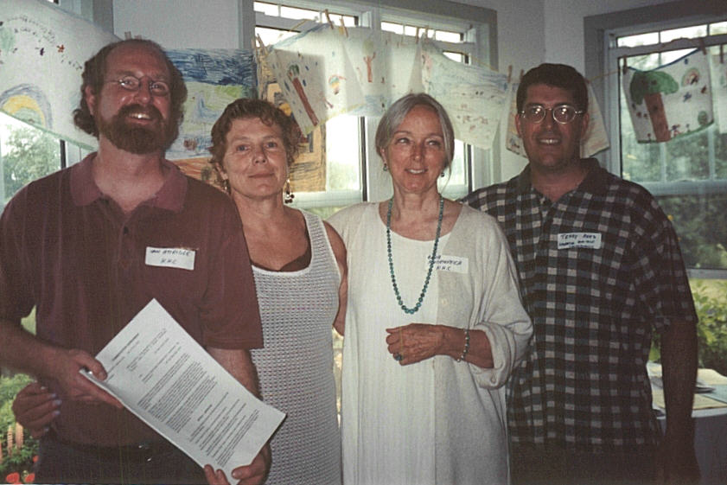
(Left to right) Ian Attridge, Mieke Schipper, Barbara H and Terry Rees with the just-signed Conservation Agreement for the Gamiing Nature Sanctuary in June 2002.

When the idea of creating a land trust in the Kawarthas was first considered, the Peterborough County Stewardship Council awarded the group its first grant that covered the incorporation expenses.

The land trust became reality when federal letters patent were issued on November 23, 2001. Ian did the legal work for both the incorporation and getting charitable status, which took effect on January 1, 2002.

Originally called the Kawartha Heritage Conservancy (KHC), the first directors were Mieke, Terry Rees of the Federation of Ontario Cottager’s Association, Phred Collins and Barbara Heidenreich, who also served as the first president.

Run as a working board at the beginning, the first staff person ever hired was a summer employee in 2003. At that time the organization’s office was in Ian’s house, but they were able to move into its own office in February 2006. AT that time they shared a space with Green Communities Canada. The office later moved to 116 Hunter Street West (2010), 156 McDonnel Street (2012) and to it’s current location at The Mount Community Centre on Monaghan Road in 20XX.

These first two decades have been remarkable in terms of what the KLT has achieved and protected. Check back here each month to learn more about the remarkable journey we’ve taken to get where we are today!

